GIS Setup for everyone

1. Control Panel: Internet Options
- (General tab) Select the “Every visit to the page” option

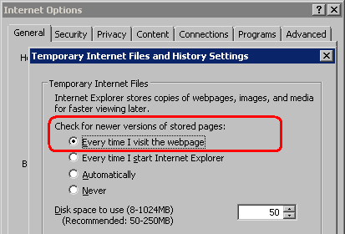

- (Security tab) Check the security settings for the Local Intranet Zone
- Automatic prompting for ActiveX controls – Enable
- Download signed ActiveX controls – Enable
- Download unsigned ActiveX controls – Enable
- Initialize and script ActiveX controls not marked as safe – Enable
- Only allow approved domains to use ActiveX without prompt – Disable
- Run ActiveX controls and plug-ins – Enable
- Automatic prompting for file downloads – Enable

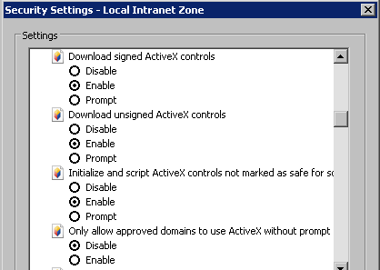
Side Note

If you see a warning message asking you to install ikcntrls.cab, close the message box and bring up the Internet Options window. Clicking “Install” does not do anything because the digital signature is outdated and you will not be able to access the GIS menubar.

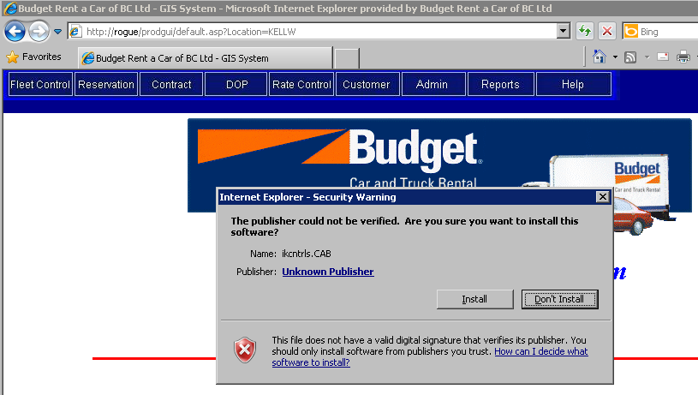

You might also see a similar message when it comes to downloading the activexviewer.cab file when you first access any report though the Reports menu. Like the previous message, clicking OK does nothing because of the digital signature.

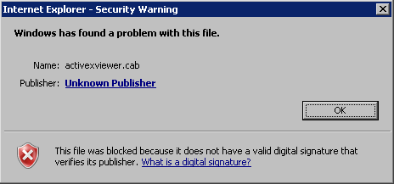

To successfully download the ikcntrls.cab and activexviewer.cab files, go to the Advanced tab of Internet Options to check the “Allow software to run or install even if the signature is invalid” box.

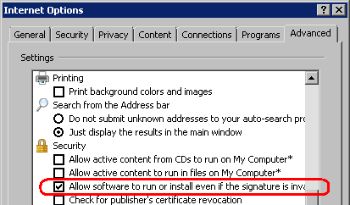

When you log in to GIS the next time, the installation of ikcntrls.cab will run successfully and you can now access the GIS menubar. Next, go to Reports/On-Request and run any report. This time, a warning message will appear asking whether you want to install activexviewer.cab. Click “Install”.

Now you can return to Internet Options to uncheck the “Allow software to run or install even if the signature is invalid” box.
2. Control Panel: Regional and Language Options
- Select “English “United States” under Standards and formats
- Ensure that ‘M/d/yyyy’ is selected for Short date format

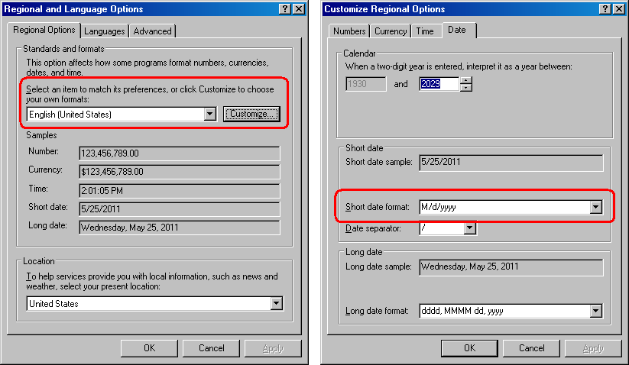

3. Ensure that the ‘Arial Narrow’ font is installed on the workstation (If Microsoft Office is installed, this step is not necessary)

4. Internet Explorer 6 – 8 (for better performance, do not open GIS in multiple tabs in one browser window)

5. Microsoft Soap Toolkit 3.0 (for emailing reservations)

6. Cute PDF writer (for the Print PDF function in Contract Check In & Contract Adjustments)

7. Settings for C:\Windows\gis.ini

Production
[GIS Settings]
Server Name=ALTIMA
GIS System Path=prodgui
Location Name=NANAD
Terminal ID=NOTERMID
Report Server=SVBVM003
Report Path=prodrpt
Credit Card Provider=EIGEN

Testing
[GIS Settings]
Server Name=ROGUE
GIS System Path=prodgui
Location Name=NANAD
Terminal ID=NOTERMID
Report Server=SVBVM016
Report Path=prodrpt
Credit Card Provider=EIGEN

For admin location, replace “Location Name” with NANAD
For resnet location, replace “Location Name” with NANRZ
For rental locations, replace “Location Name” with your location name (eg. NANAP, KELLW..)

8. GIS URL
http://rogue/prodgui/gissignon.htm

Substitute the blue highlighted part in the URL with the “GIS System Path” from the gis.ini file to switch between production and testing.

9. GIS Look and Feel
- Select the “Windows Classic” theme

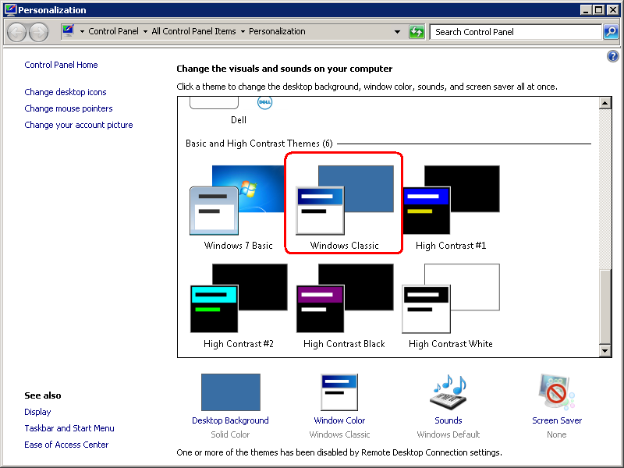

- Open up the Window Color window and select “3D Objects” from the Item drop down box, select the light gray color (Red: 192; Green: 192; Blue: 192; Hue: 160; Sat: 0; Lum: 181)
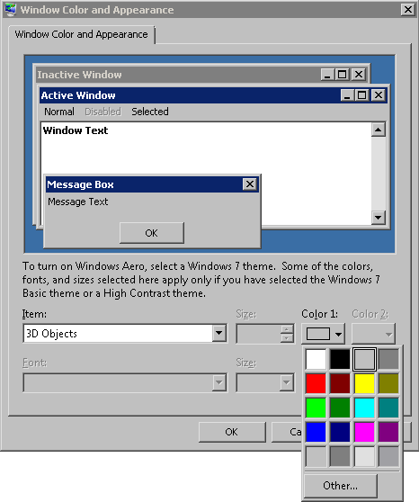

Additional GIS Setup for accounting/customer service staff
(To access the Air Miles Adjustment and Accounting Export modules)

1. Some .Net framework

Additional GIS Setup for rate and fleet department
(To access the Fleet Accounting Export module and Maintenance tools)

1. Some .Net framework
2. Microsoft Access

